
Holy Cross College

Semester 2 Examination 2015

Question/Answer Booklet

Year 10 Science
Please place your student identification label in this box
(General)

Student Name
Student’s Teacher

Time allowed for this paper

Reading time before commencing work: 10 minutes
Working time for paper: 110 minutes

Materials required/recommended for this paper

To be provided by the supervisor

This Question/Answer Booklet
Data Sheet

To be provided by the candidate

Standard items: pens, pencils, eraser, correction fluid, ruler, highlighters.
Special items: non-programmable calculators satisfying the conditions set by the School Curriculum and Standards Authority for this course.

Important note to candidates

No other items may be taken into the examination room. It is your responsibility to ensure that you do not have any unauthorised notes or other items of a non-personal nature in the examination room. If you have any unauthorised material with you, hand it to the supervisor before reading any further.

Structure of this paper

Section | Number of questions available | Number of questions to be answered | Suggested working time  (minutes) | Marks available | Percentage of exam
Section One:  Multiple Choice | 35 | 35 | 35 | 35 | 25
Section Two:  Short Answer | 15 | 15 | 55 | 91 | 63
Section Three:  Comprehension | 1 | 9 | 20 | 18 | 12
 |  |  |  | 144 | 100

Instructions to candidates

1. The rules for the conduct of examinations at Holy Cross College are detailed in the College Examination Policy. Sitting this examination implies that you agree to abide by these rules.

2. Write your answers in this Question/Answer Booklet.

3. Working or reasoning should be clearly shown when calculating or estimating answers.

4. You must be careful to confine your responses to the specific questions asked and to follow any instructions that are specific to a particular question.

5. Spare pages are included at the end of this booklet. They can be used for planning your responses and/or as additional space if required to continue an answer.

• Planning: If you use the spare pages for planning, indicate this clearly at the top of the page.
• Continuing an answer: If you need to use the space to continue an answer, indicate in the original answer space where the answer is continued, i.e. give the page number.
• Fill in the number of the question(s) that you are continuing to answer at the top of the page.

SECTION 1 MULTIPLE CHOICE (35 marks)

Choose the best answer for each question in the Multiple Choice Question booklet.

Mark your selection with a cross.

1 | (a) | (b) | (c) | (d) |  | 31 | (a) | (b) | (c) | (d)
2 | (a) | (b) | (c) | (d) |  | 32 | (a) | (b) | (c) | (d)
3 | (a) | (b) | (c) | (d) |  | 33 | (a) | (b) | (c) | (d)
4 | (a) | (b) | (c) | (d) |  | 34 | (a) | (b) | (c) | (d)
5 | (a) | (b) | (c) | (d) |  | 35 | (a) | (b) | (c) | (d)
6 | (a) | (b) | (c) | (d)
7 | (a) | (b) | (c) | (d)
8 | (a) | (b) | (c) | (d)
9 | (a) | (b) | (c) | (d)
10 | (a) | (b) | (c) | (d)
11 | (a) | (b) | (c) | (d)
12 | (a) | (b) | (c) | (d)
13 | (a) | (b) | (c) | (d)
14 | (a) | (b) | (c) | (d)
15 | (a) | (b) | (c) | (d)
16 | (a) | (b) | (c) | (d)
17 | (a) | (b) | (c) | (d)
18 | (a) | (b) | (c) | (d)
19 | (a) | (b) | (c) | (d)
20 | (a) | (b) | (c) | (d)
21 | (a) | (b) | (c) | (d)
22 | (a) | (b) | (c) | (d)
23 | (a) | (b) | (c) | (d)
24 | (a) | (b) | (c) | (d)
25 | (a) | (b) | (c) | (d)
26 | (a) | (b) | (c) | (d)
27 | (a) | (b) | (c) | (d)
28 | (a) | (b) | (c) | (d)
29 | (a) | (b) | (c) | (d)
30 | (a) | (b) | (c) | (d)

SECTION 2 SHORT ANSWER (91 marks)

Attempt all questions. Write your answers in the spaces provided.

1. How well a metal conducts electricity is given the symbol K. The bigger the K number, the better the metal conducts electricity. Look at the table below.

Metal | K number
cobalt | 15
gold | 45
lead | 5
silver | 60
iron | 10

a. Which metal is the third best at conducting electricity? (1 mark)

_______________________________

b. Copper is a better conductor than gold. Copper, however, is not as good as silver. In what range would copper’s K number be? (1 mark)

________________________________________________________

c. If lead is the standard, its K number is changed to ‘one’. The new K number of cobalt would be 3, while for gold it would be 9. What would the new K numbers for silver and iron be? (2 marks)

silver _________ iron _________

2. Read the following newspaper article. It appeared in the Brisbane Courier Mail on
April 18 1990.

Use this article to answer the questions below.
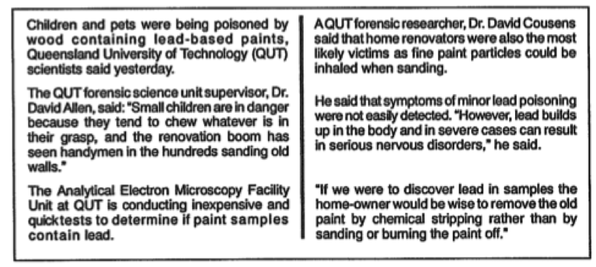
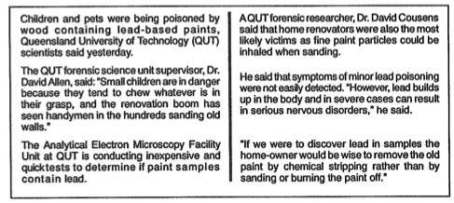
a. Which two groups of people are at risk from lead poisoning? (1 mark)

____________________________________________________________

b. What are you advised to do if you are renovating an old house? (2 marks)

___________________________________________________________________

___________________________________________________________________

___________________________________________________________________

___________________________________________________________________

___________________________________________________________________

c. Give one reason why lead is a dangerous chemical. (1 mark)

___________________________________________________________________

___________________________________________________________________

___________________________________________________________________

___________________________________________________________________

___________________________________________________________________
d. During the term that you were studying Chemistry, you did an extensive study of one room in your house where chemicals were being stored and/or used. Describe one of the more ‘dangerous’ chemicals by listing:

i) the name of the chemical, (1 mark)

ii) why it is dangerous, (2 marks)

___________________________________________________________________

___________________________________________________________________

___________________________________________________________________

___________________________________________________________________

___________________________________________________________________

___________________________________________________________________

and iii) how you go about making sure that it doesn't cause harm to other people, pets and the environment. (2 marks)

___________________________________________________________________

___________________________________________________________________

___________________________________________________________________

___________________________________________________________________

___________________________________________________________________

___________________________________________________________________

___________________________________________________________________

___________________________________________________________________

___________________________________________________________________

___________________________________________________________________

e. i) There are chemicals that we use constantly in our homes or in some of your work places. Name five products that you have studied and used, and give an idea of how these are used. (10 marks)

Name: _____________________________________________

Use: ______________________________________________________

___________________________________________________________________

___________________________________________________________________

Name: _____________________________________________

Use: ______________________________________________________

___________________________________________________________________

___________________________________________________________________

Name: _____________________________________________

Use: ______________________________________________________

___________________________________________________________________

___________________________________________________________________

Name: _____________________________________________

Use: ______________________________________________________

___________________________________________________________________

___________________________________________________________________

Name: _____________________________________________

Use: ______________________________________________________

___________________________________________________________________

___________________________________________________________________
ii) Why do people still like to use some of these chemicals knowing that they may be harmful? Where do they go to find out more about the dangers of some of these chemicals? (4 marks)

___________________________________________________________________

___________________________________________________________________

___________________________________________________________________

___________________________________________________________________

___________________________________________________________________

___________________________________________________________________

___________________________________________________________________

___________________________________________________________________

___________________________________________________________________

3. A burette is used to accurately add one solution to another. The drawing below shows an experiment using a burette.

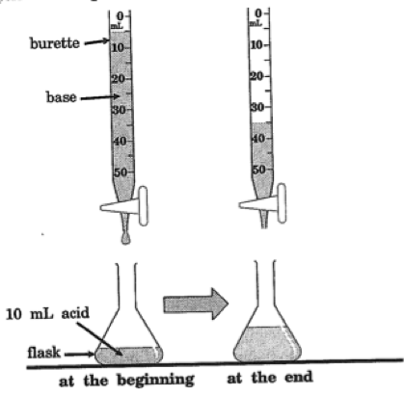

a. How many mL (millilitres) of base was added to the flask from the burette?
(1 mark)

____________________________
b. Which one below would you use to measure the acid accurately before putting it in the flask? Circle or shade in the correct answer. (1 mark)

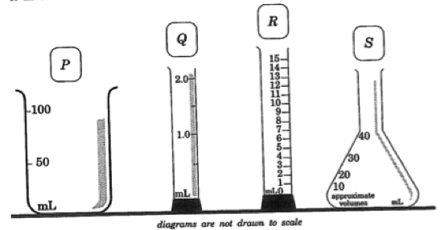

c. A burette should not be rinsed with water before using it. Suggest a reason why. (2 marks)
___________________________________________________________________

___________________________________________________________________

___________________________________________________________________

___________________________________________________________________

___________________________________________________________________

4. The instructions for testing pool-water and the chemicals used are given below. The instructions came from the United States of America and therefore use inches
(1 in = 2.5 cm).

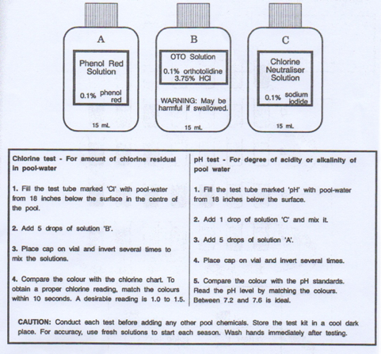

a. Tom decided to test his pool-water for chlorine (Cl). He rinsed the Cl vial with pool water. He took some water about 40 cm from below the surface of the water near the edge. He added 5 drops of solution ‘A’ that he bought a couple of years ago. He placed the lid on the vial and shook it a few times. After about 10 minutes, he matched up the colours. He got a reading of 1.9 for the Cl reading.

Tom made four mistakes in his method. What are they? (4 marks)

i) __________________________________________________________

__________________________________________________________

__________________________________________________________

ii) __________________________________________________________

__________________________________________________________

__________________________________________________________

iii) __________________________________________________________

__________________________________________________________

__________________________________________________________

iv) __________________________________________________________

__________________________________________________________

__________________________________________________________

__________________________________________________________

b. State one thing you should do when using the solutions safely. (2 marks)

______________________________________________________________

______________________________________________________________

______________________________________________________________

______________________________________________________________

______________________________________________________________

5. Adding certain chemicals to unhealthy plants helps them to grow better. Look at the information below.
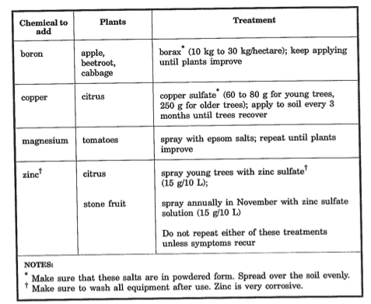

a. What is the maximum amount of borax you would add to 20 hectares of apples? (1 mark)

______________________________

b. Describe briefly how you would test whether using Epsom salts makes tomatoes grow better. (4 marks)

___________________________________________________________________

___________________________________________________________________

___________________________________________________________________

___________________________________________________________________

___________________________________________________________________

___________________________________________________________________

___________________________________________________________________

___________________________________________________________________

___________________________________________________________________

___________________________________________________________________

___________________________________________________________________

___________________________________________________________________

___________________________________________________________________

___________________________________________________________________

___________________________________________________________________

___________________________________________________________________

___________________________________________________________________

___________________________________________________________________

c. What does the information say you should do when adding all of these salts?
(2 marks)

___________________________________________________________________

___________________________________________________________________

___________________________________________________________________

___________________________________________________________________

___________________________________________________________________

___________________________________________________________________

___________________________________________________________________

___________________________________________________________________

6. You are asked by your manager at work to trial three different detergents (A, B and C) to see which one will wash and clean the pots, pans and trays you use the quickest and most effectively.

Write up an experiment where you scientifically prove the effectiveness of each of the detergents. You MUST write it up as a scientific report so that he/she can be certain of your decision. Remember that someone else must be able to follow your report, do it themselves using your method, and achieve the same results that you did.

Write it out using the following headings.

(Note: bullet points or short-answer statements may be used.)

AIM:

VARIABLES: independent (changed), dependent (measured) and controlled.

HYPOTHESIS:

MATERIALS REQUIRED:

METHOD USED:

RESULTS: make some up into a table.

CONCLUSION: from your made up results making sure you say exactly why the detergent makes a good choice.
(10 marks)

Aim: _____________________________________________________________

__________________________________________________________________

Variables: Independent - __________________________________________

Dependent - ___________________________________________

Controlled - _____________________________________________

___________________________________________________________________

___________________________________________________________________

Hypothesis: ________________________________________________________

___________________________________________________________________
___________________________________________________________________

Materials: __________________________________________________________

___________________________________________________________________

___________________________________________________________________

___________________________________________________________________

___________________________________________________________________

___________________________________________________________________

___________________________________________________________________

___________________________________________________________________

___________________________________________________________________

___________________________________________________________________

Method: ___________________________________________________________

___________________________________________________________________

___________________________________________________________________

___________________________________________________________________

___________________________________________________________________

___________________________________________________________________

___________________________________________________________________

___________________________________________________________________

___________________________________________________________________

___________________________________________________________________

___________________________________________________________________

___________________________________________________________________

___________________________________________________________________

___________________________________________________________________

___________________________________________________________________

___________________________________________________________________
Results: __________________________________________________________

___________________________________________________________________

___________________________________________________________________

___________________________________________________________________

___________________________________________________________________

___________________________________________________________________

___________________________________________________________________

___________________________________________________________________

___________________________________________________________________

___________________________________________________________________

___________________________________________________________________

___________________________________________________________________

___________________________________________________________________

___________________________________________________________________

___________________________________________________________________

___________________________________________________________________

___________________________________________________________________

___________________________________________________________________

___________________________________________________________________

___________________________________________________________________

___________________________________________________________________

___________________________________________________________________

Conclusion: ________________________________________________________
___________________________________________________________________

___________________________________________________________________

___________________________________________________________________

7. Reaction time is the time taken to react to a stimulus (change in surroundings).

List 3 things that may affect reaction time and explain how each effect changes the reaction time. (3 marks)

(i)

(ii)

(iii)

8. a. Explain how a fatigued (tired) driver could cause an accident on the road.
(2 marks)

b. List 3 ways you can reduce fatigue (tiredness) as a driver. (3 marks)

(i)

(ii)

(iii)

9. Explain the difference between reaction distance and braking distance. (2 marks)

Reaction distance is

Braking distance is

10. Explain three ways that being under the influence of alcohol can affect your driving ability? (3 marks)

(i)

(ii)

(iii)

11. List 2 reasons why it is important for people over the age of 80 to re-sit their driver’s licence every few years. (2 marks)

(i)

(i)

12. What is the difference between a first and second collision in a car crash. (2 marks)

First collision is

Second collision is

13. (a) What is the difference between a primary and secondary safety feature? (2 marks)

Primary safety feature is

Secondary safety feature is

(b) Explain why these safety features are effective. (2 marks)

14. Read the below table and answer questions below.

SERIOUS CRASHES
CRASH TYPE | PERTH |  | COUNTRY |  | TOTAL
Rear end | 183 | 14% | 32 | 4% | 215 | 10%
Head on | 38 | 3% | 48 | 6% | 86 | 4%
Side Swipe  -same direction | 75 | 6% | 28 | 3% | 103 | 5%
-opposite direction | 21 | 1% | 22 | 3% | 43 | 2%
Right Angle | 307 | 23% | 71 | 9% | 378 | 18%
Turn Across | 161 | 12% | 30 | 4% | 191 | 9%
Hit Pedestrian | 181 | 14% | 62 | 8% | 243 | 11%
Hit Object/Animal | 234 | 18% | 267 | 33% | 501 | 24%
Non-collision | 87 | 6% | 232 | 29% | 319 | 15%
Unknown | 37 | 3% | 5 | 1% | 42 | 2%
Total | 1,324 | 100% | 797 | 100% | 2,121 | 100%

a. What is the most common form of serious crash? (1 mark)

b. Where do most head-on crashes occur? (1 mark)

c. Why would more rear end crashes occur in Perth than in the
country? (1 mark)

d. Most people blame “the other driver” for accidents. Does the data support this? Explain your answer. (2 marks)

e. Describe an accident that would be a “non-collision”, and explain how a death could occur in this situation. (2 marks)

15. Sir Isaac Newton discovered the Three Laws of Motion.

a. Fill in the following definitions of the three laws, using one word or a phrase to fill in the blank spaces.

The same word may be used more than once in a definition.

Newton's First Law

Unless a force acts on an object, the object’s motion .
If it is at rest, it .
If it is moving, it continues to move in a line at a speed. (2 marks)

Newton's Second Law

The acceleration of an object is dependent on the size of the acting on it and the of the object. A larger increases the acceleration of an object, and increasing the decreases the acceleration of the object. (2 marks)

Newton's Third Law

To every force (reaction) there is an equal and force (reaction). (1 mark)

b. For each of the following situations, state the law of motion that applies and the reason for your choice.

i) A car can accelerate faster with one person than when it contains five people. (2 marks)

Law

Reason

ii) A plasticine figure is placed on a small trolley and released down a ramp. A barricade is placed at the bottom of the ramp. When the trolley hits the barricade, the plasticine figure flies forward. (2 marks)

Law

Reason

THIS PAGE HAS BEEN DELIBERATELY LEFT BLANK.
SECTION 3 COMPREHENSION (18 marks)

Read the article and highlight important words and phrases; then answer the questions that follow. Write your answers in the spaces provided.

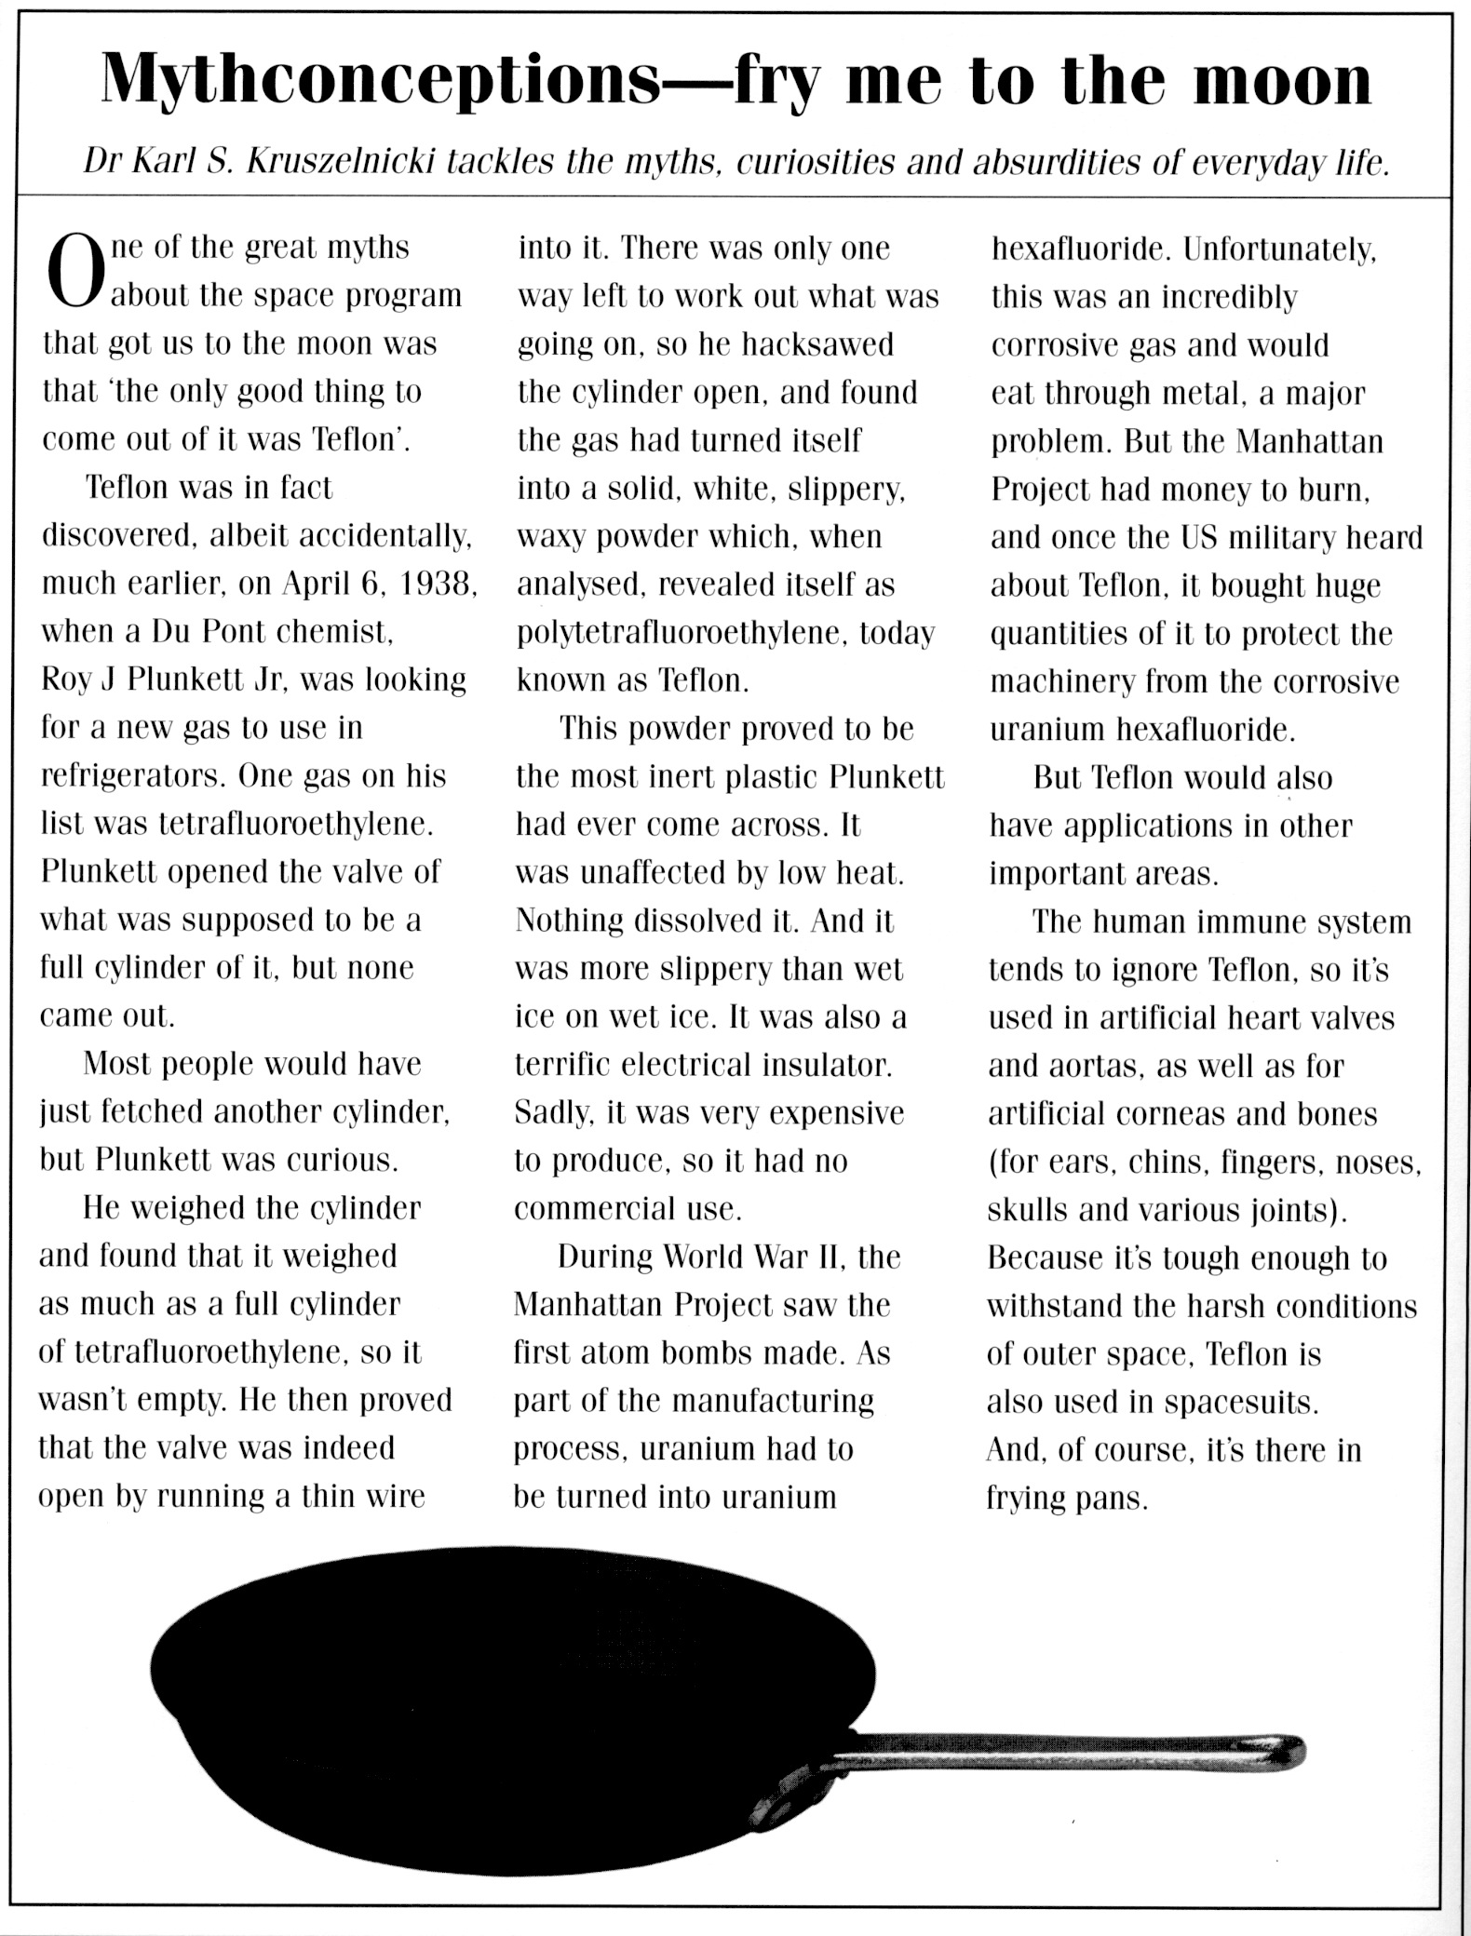

1. When was Teflon discovered and by whom? (2 marks)

2. What is the correct chemical name of Teflon? (1 mark)

3. Describe what Teflon looks like. (2 marks)

4. What properties make Teflon an extremely useful material? (2 marks)

5. Teflon is said to be inert - what does this mean? (1 mark)

6. What research was the inventor doing when he discovered Teflon? (1 mark)

7. What stopped Teflon from being commercially produced in the early days? (1 mark)

8. Is Teflon a metal or a plastic? Give one piece of evidence. (2 marks)

9. Complete the following table about the uses of Teflon.

(6 marks)

LOCATION | USE | PROPERTY RELATED TO USES
Body
Space
Kitchen

END OF EXAMINATION

